Android Build Process

Building android app runs through two steps
- Compilation and packing
- Signing
- While building process we start by implementing android assets that done by “appt” packing tool
- Then move through java compiler to transfer from .java/.aidl to .class files
- Then .class files compiled along with any third-party libraries into a classes.dex file
- Then with other resources run through “apkbuilder” to produce .apk file
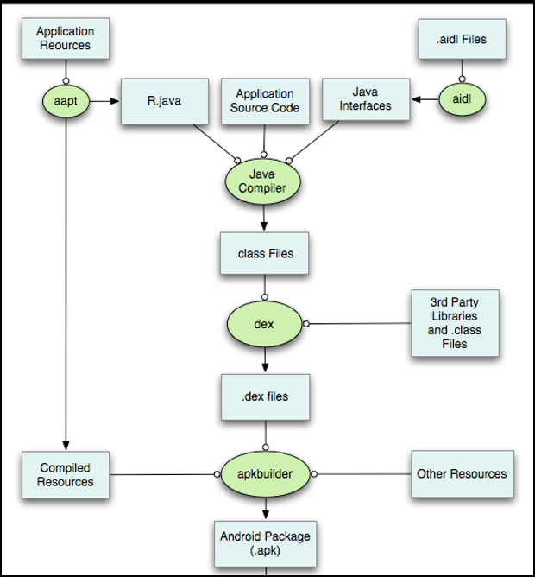

Apk structure
Apk file is a compressed archive contain images, code & audio you can open it by any zip app after change the extension to .zip
Once you decompressed will looks like that
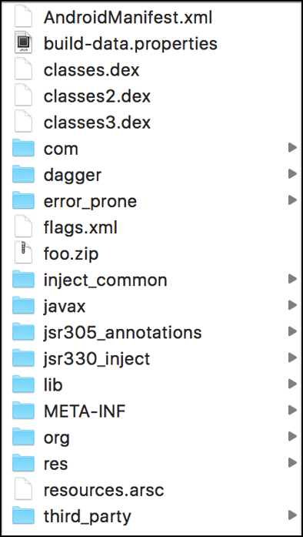

AndroidMainfest.xml
AndroidMainfest.xml located in binary format after converting it to readable format lets describe it step by step

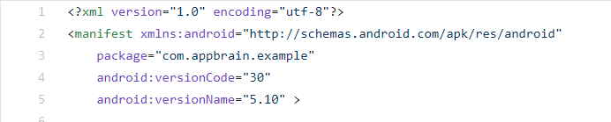
Package element referee to app name
Android version name/code referee to the minimum android version the app would run at.
- Android is open source, so some company make their own systems OEMs (Original Equipment Manufacturer) they also referred as bloatware
- That means some mobiles will not get any updates and that will make problems because a lot of them are security update and that put security of the customers under risk and make the customers able to make lawsuits to get update, that actually happened to Samsung
  - http://thehackernews.com/2016/01/samsung-security-update.html
“there are 65,535 methods which can be stored in a single dex file”
- Most programs have only single dex file because dalvik vm only supports one per apk
- /lib directory used for storing library and precompiled code
- Linux shared objects stores in .so files
- This library created by the developer or from third-party
- .So if the attacker found a way to modify or replace them and get them execute that could result in arbitrary code execution
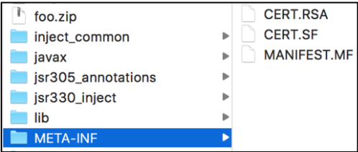
In META_IF file contain files related to the Integrity and authenticity of the application
- MANIFEST.MF: contain list of all resource’s files and there SHA1
- CERT.RSA: the developer signing certification
- CERT.SF contain SHA1 of MANIFEST.MF data
“/res directory contain all resources such as images”

- Android devices will not run unsigned .apk files whether you’re building for testing or deployment
- Public key included in a digital file known as x.509 certificate this certificate used to verify the identity of the entity
- Signing means encrypt certificate with the private key to verify that the data comes from trusted source without modification that done decrypted the encrypted hashes with the public key and encrypt the value then compare between them
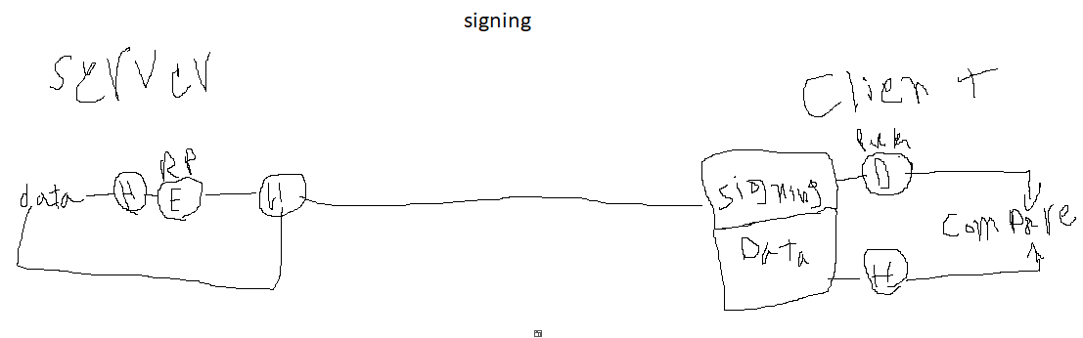
- Self-signing certificates are just fine and no less secure
- Android use the certificate as binary blob
- Binary Large Object (BLOB) is a collection of binary data stored as a single entity. Blobs are typically images, audio or other multimedia objects, though sometimes binary executable code is stored as a blob.
- They can exist as persistent values inside some databases or exist at runtime as program variables in some languages.
- Signing the apk is built-in process in android studio IDE and largely abstracted from the developer
- We can use” jarsigner” to accomplish this task outside the IDE
- At the first we need to generate private key using keytool
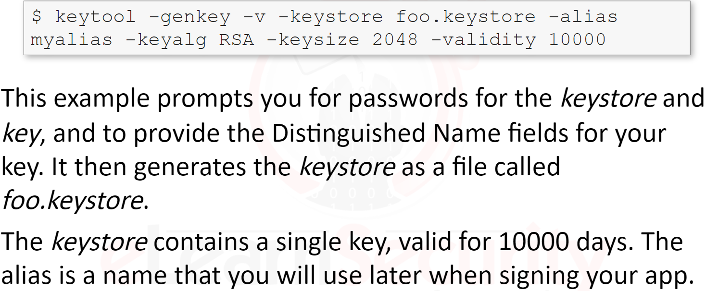
- Then use jarsigner tool to sign it
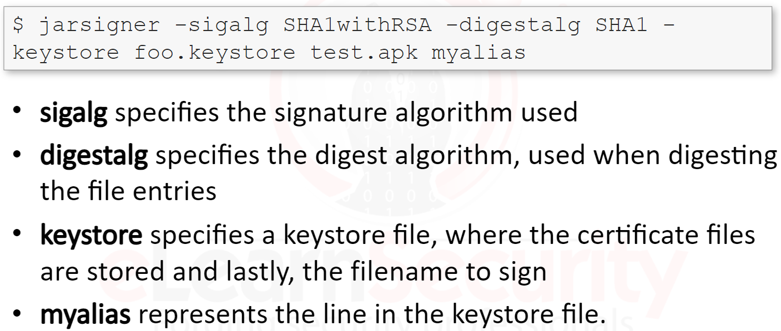
you can verify the signing of existing apk with jarsigner
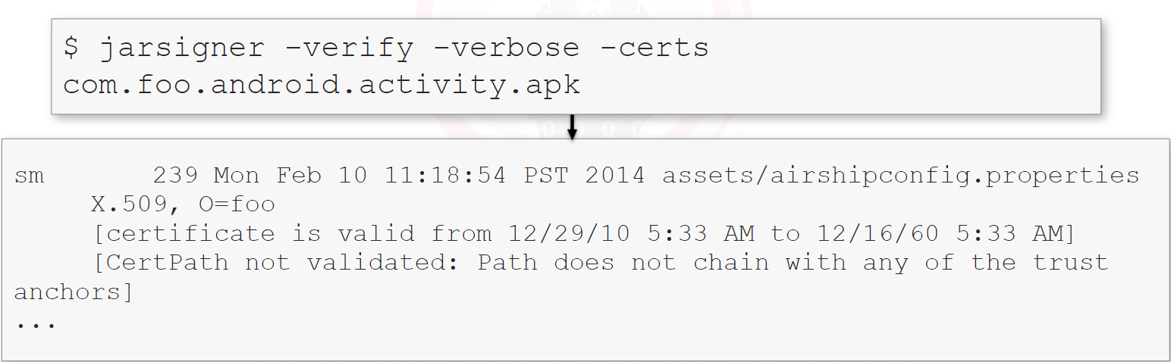

- We can verify the hashes in the MAINFEST.MF using openssl tool as shown
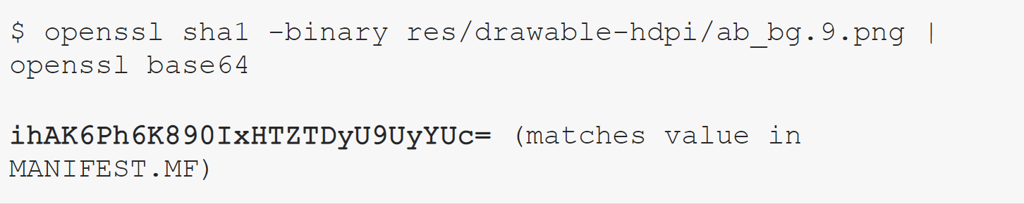

- CERT.RSA file in binary format we can convert it from DER to PEM with openssl also
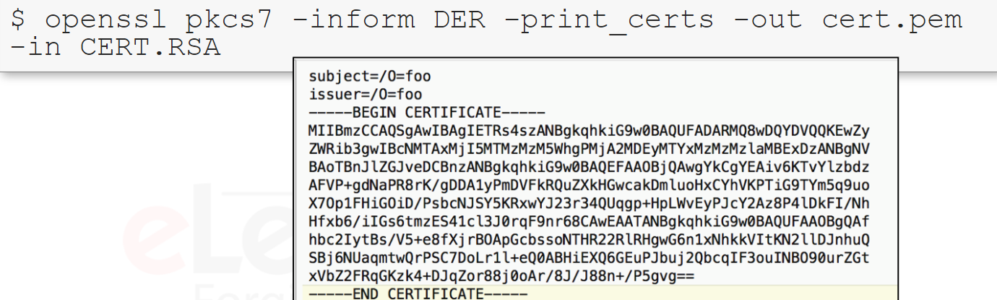
- To see the details for public key in the certificate we can run the follow
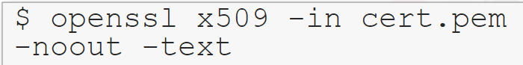
- We can verify manifest’s hashes by openssl also
- This verifies that the manifest itself, including the file hashes it contains haven’s been modified, since the app was built.
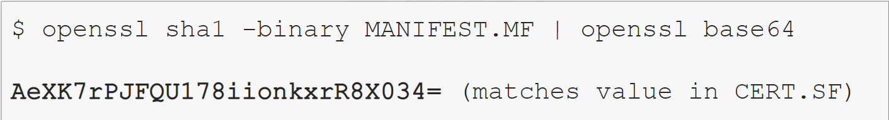
- Apk mush signed with the same certificate which is not typically the case with java that because OTA(Over-The-Air) update files are distributed and validated

Android studio has two signing modes
- Debug
  - For testing purposes and never used to sign applications that are published to the public
  - This allows you to run apps directly connected via USB or on emulators
- Release
  - For apps which are bounded for consumer devices
- Apk must aligned after it is signed that done using” zipalign” tool

